**Kind-Heart**

**Local Food Waste Reduction Web Application**

**Milestone meeting 01**

**Names of the team members**

* **Thidas Hansaka Rathnayaka - CL/HDCSE/CMU/114/92**
* **Oshitha Kalhara Senarathna - CL/HDCSE/CMU/114/140**
* **Aruna Kaldera - CL/HDCSE/CMU/114/124**
* **Omindu Dulen - CL/HDCSE/CMU/114/94**

**Requirement Gathering And Analysis**

**Feasibility Study Report**

**Introduction**

Our donation web application Kind-Heart, in a world where millions suffer from hunger, reducing food waste has become a vital global priority. The **Kind-Heart Local Food Waste Reduction Web Application**, this application connects food donors with charities, food banks, and individuals in need, promoting a community-driven initiative to reduce waste and combat hunger.

**Vertex Digital Solutions (VDS) is collaborating with the ICBT Campus Rotaract Club to address a significant challenge: the inefficiencies in their manual donation process. The Rotaract Club, known for its charitable efforts, currently relies on time-consuming methods to find donors, coordinate with recipients, and arrange for the delivery of donations, including clothes and other essential supplies. This proposal outlines the development of a comprehensive web application that will streamline these operations, making it easier for the club to manage donations and expand its support for orphanages, individuals in need, and other community causes. While the club is interested in launching a food donation program to reduce waste from events and businesses, logistical constraints currently limit their ability to handle perishable items.**

The Kind-Heart Donation Web App transforms the donation process, making it easier and more rewarding for donors while streamlining operations for the Rotaract Club. Through this app, businesses, hotels, individuals, and other donors can quickly list their donations—whether food, clothing, or essential supplies—with just a few clicks, saving them time and effort.

Once a donation is listed, recipients such as orphanages, elder homes, and individuals can claim it directly through the app. After a donation is claimed, the Rotaract Club steps in to manage the collection and delivery, ensuring that items reach those in need safely and efficiently. This system allows donors to experience the joy and satisfaction of giving without having to worry about the logistics.

The app also fosters a sense of community and gratitude. Donors can earn badges for their contributions, motivating them to give more and be recognized for their efforts. An integrated chat system allows for direct communication between donors and recipients, enhancing transparency and building connections. This feature enables users to discuss donation details, coordinate logistics, and foster relationships, making the entire experience more personal and engaging. Meanwhile, the platform simplifies the club’s management of donations, providing a central hub for tracking, organizing, and coordinating efforts.

Beyond facilitating donations, the app aims to inspire a culture of kindness and sustainability. The “Sustainable Living Tips” blog offers practical advice on topics like reducing waste and reusing items, encouraging users to make greener choices in their daily lives. By connecting donors and recipients and empowering the Rotaract Club to serve more effectively, the Kind-Heart Donation Web App not only makes giving easier but also nurtures a community that cares.

1. **Technical Feasibility**

**Scope**

* Develop a user-friendly website for donation web application
* Integrate functionalities for registering and login in, requesting donations, add donations, with 4 user interfaces admin, donor, recipient, delivery man.

**Technology stacks**

**Front-End technology - HTML, CSS, and JavaScript**

**Back-End Technologies – PHP, MySQL**

**Development Environment and Server - WAMP Server, Version Control – Git**

**Design and UI/UX Tools – Figma, Miro**

**Key Functionalities**

1. **User Registration and Authentication**:

* **Registration for Donors and Recipients**: Users can register either as donors or recipients by providing essential personal details such as name, contact information, address, and, optionally, any organizational affiliations.
* **Secure Login and Authentication**: The system includes a secure login process requiring users to input their username and password twice for confirmation. Both roles (donors and recipients) log in through this method.
* **Dashboard Access**: After logging in, users are directed to their respective dashboards where they can manage donations, requests, deliveries, and ratings.

**2. Donor Dashboard**:

* **Personalized Donor Dashboard**: Donors have access to a custom dashboard that shows their rating, donation history, and how many people they've helped.
* **Create and Manage Donations**: Donors can list new donations, categorized as food, clothes, or other supplies. They can input specific details such as item name, quantity, clothing size (if applicable), expiration date, description, and auto-filled or editable location.
* **Track Requests**: Donors can view the list of requests made by recipients, with each request displaying requester details, quantity requested, pickup time, and status (pending, accepted, or canceled).
* **Handle Requests and Delivery**: Once a request is accepted, donors proceed to choose between self-delivery or company delivery, paying the necessary delivery fees. The donation process is tracked until final delivery and status updates are shown in the dashboard.
* **Rating and Badges**: Donors can rate recipients after successful deliveries, and they earn badges based on the number of donations completed (e.g., bronze, silver, gold), enhancing their reputation in the system.

3. **Recipient Interface**:

* **User-Friendly Recipient Dashboard**: Recipients have access to a simplified interface where they can browse and claim donations categorized as food, clothes, or supplies. They can view available items with relevant details like donor name, donor rating, and donation details.
* **Claim Donations**: Recipients can claim items by filling out a form with their pickup or delivery preferences and specifying the requested quantity. The system also allows recipients to opt for delivery services, if applicable.
* **Track Requests and Status Updates**: After claiming an item, recipients can track the status of their requests in real-time (pending, approved by admin, accepted by donor, in delivery, etc.).
* **Rate Donors**: After receiving the donation, recipients can rate the donor based on their experience, adding transparency and feedback to the system.

**4. Admin Dashboard:**

* **Admin Overview:** Admins have access to a centralized dashboard that provides a comprehensive view of all donation activities, requests, and user management functions. The dashboard allows them to oversee and approve requests, monitor user interactions, and handle complaints.
* **Manage Donations**: Admins can approve or reject requests, track donation status, and ensure smooth delivery operations. They oversee the process from request to final delivery.
* **User and Role Management**: Admins manage the roles of users (donor, recipient, delivery person), ensuring that the right users have the necessary permissions to access their respective features. They can also assign or revoke roles as needed.
* **View Complaints and Notices:** Admins can address user complaints and post notices related to system updates, events, or relevant causes for the user community.

**5. Delivery Person Dashboard:**

* **Manage Deliveries:** Delivery personnel can view all pending delivery tasks, with detailed information including the recipient’s name, address, and contact information. The delivery person can update the status of deliveries, marking them as "In Progress" or "Delivered."
* **Delivery Tracking:** The dashboard allows delivery personnel to track the history of completed deliveries. They can also view feedback from recipients regarding the service provided.
* **Optimized Route Guidance:** Integrated location-based services assist delivery personnel in planning the most efficient routes for multiple deliveries, reducing time and costs.

**7. Security and Data Integrity**

* **Robust Security Measures**: The application implements comprehensive security protocols to protect sensitive user data, ensure safe transactions, and maintain the overall integrity of the system. This includes encryption of personal data and secure handling of delivery payments.
* **Fraud Prevention**: Measures are also put in place to prevent fraud, ensuring that all donations and claims are legitimate and securely processed.

8. **Mobile-Friendly Design**:

* **Responsive Design**: The web application is built with a mobile-responsive design, ensuring that users can access the platform easily from any device, whether they are making donations, claiming items, or tracking deliveries. This enhances user convenience, particularly for busy donors and recipients on the move.

9. **Performance Optimization**:

* **Fast Loading Times**: The application is optimized for fast performance, with quick loading times even during peak usage. This ensures that users can navigate the system, claim donations, or create new listings without unnecessary delays.
* **Efficient Data Management**: Efficient data handling ensures smooth transaction processing and page rendering, contributing to a seamless experience for users across the platform

**Non-Functional Requirements**

1. **Scalability:**

* The system should handle increasing traffic as more users participate in the platform, ensuring that it can grow with the community's needs without performance degradation.

1. **Reliability:**

* The application must be consistently available and perform reliably, providing a dependable platform for users to donate or receive items whenever needed.

1. **Security:**

* Strong security measures will be implemented to protect user data, prevent unauthorized access, and ensure secure transactions, building user confidence in the platform.

1. **Usability:**

* The user interface should be intuitive and easy to navigate, ensuring that users of all technical backgrounds can efficiently use the system to find, donate, or receive items.

1. **Performance:**

* The system will be optimized for fast loading times and responsiveness, minimizing wait times and enhancing the overall user experience.

1. **Economic Feasibility**

**This is a non-profit project**

|  |  |  |
| --- | --- | --- |
| **Category** | **Cost (LKR)** | **Description** |
| **Domain & Hosting Fees** | 25,000 | Annual cost for registering and hosting the domain. |
| **Development Expenses** | 150,000 | Expenses for coding, testing, and system integration during the development phase. |
| **Maintenance Costs** | 30,000 | Yearly costs for updates, support, and performance optimization. |
| **Training Costs** | 10,000 | Cost of training staff and stakeholders on system usage. |
| **Security Costs** | 20,000 | |  | | --- | |  |  |  | | --- | | Costs associated with implementing and maintaining security features. | |
| **Miscellaneous Costs** | |  | | --- | | 15,000 | | Additional expenses for tools, licenses, or other unforeseen costs. |
| **Total** | **250,000 LKR** | Total estimated cost for development and maintenance. |

1. **Operational Feasibility**

**Human Resources:**

* **Project Manager:** Oversee the project development.
* **Software Engineer:** Develop the website and backend systems.
* **UI/UX Designer:** Design the user interface and user experience.
* **Database Engineer:** Design and manage the database.
* **System Analyst:** Analysis and design of systems.
* **Quality Assurance:** Checking the quality of products.

**User Adaptation**  
The web application assumes that users, including donors and recipients, are familiar with basic digital interfaces. By designing the platform with simplicity and user-friendliness in mind, the system ensures a smooth onboarding process. The user-friendly dashboards will allow for easy donation management, tracking requests, and communicating with other users. This facilitates a quick adaptation for users accustomed to managing their activities online.

**Integration with Existing Systems**  
Recognizing that many users already use digital tools for daily tasks, the application has been developed with compatibility in mind. It ensures seamless integration with common systems like social media platforms for authentication and various delivery systems. This minimizes any disruption to the users' current practices while improving the ease of donations and requests.

**Resource Availability**  
The application assumes that most users will have access to basic devices such as smartphones or computers, along with stable internet connectivity. Since the platform is designed to be mobile-responsive and web-based, it will remain accessible to users on various devices without the need for any specialized hardware or software.

**Training Requirements**  
The platform is built on the assumption that users have a basic understanding of navigating web applications. To support any gaps in knowledge, it offers detailed tutorials and support resources that guide users through each feature. These resources help ensure that even users who are new to online donation platforms can quickly learn to use the system.

**Scalability**As the platform expects a growing user base, the underlying architecture has been designed to scale with demand. Whether the number of users increases, or the types of donations expand, the application can handle this growth without compromising performance or user experience.

1. **Scheduling Feasibility**

**Timeline:**

* **Project Initialization & Requirements Gathering:** 4 days
* **System Design Phase:** 6 days
* **Content Creation Phase:** 5 days
* **Development Phase:** 29 days
* **Testing Phase:** 7 days
* **Deployment:** 5 days

**Total Duration: 52 days (1.5 months)**

**Requirement Gathering**

We conducted individual interviews with key stakeholders, such as charity organizers, food donors (restaurants and grocery stores), and community recipients, to gain deeper insights into their needs, preferences, and challenges related to food waste reduction and donation.

**Charity Organizers:**

* What motivated your organization to focus on food donation?
* What are the current challenges you face in coordinating food donations?
* How do you manage donor-recipient communication and delivery logistics?
* What features would make a food donation web application more efficient for your organization?
* How does your organization ensure the quality and safety of donated items?
* In what ways do you think the platform could support larger-scale donations?

**Food Donors (Restaurants & Grocery Stores):**

* What types of food items do you typically have in surplus?
* How do you currently handle food waste or surplus items?
* What challenges do you face in donating food regularly?
* How do you see a digital platform facilitating smoother donation processes?
* How important is the tracking and feedback on donations to your business?

**Community Recipients (Orphanages, Food Banks, Individuals in Need):**

* What challenges do you face in accessing food donations?
* How do you typically find donors or receive information about available donations?
* What would make it easier for you to claim donations?
* How do you prefer to receive donations (e.g., delivery or pick-up)?
* What features would help improve the experience of using a donation platform?

**Requirements Gathering from Surveys**

**Resource Identification**

Resource identification is a critical phase in the development of the **Kind-Heart Local Food Waste Reduction Web Application**, which ensures all required assets are allocated effectively to meet the project's objectives. This process is key for assembling the right team and acquiring the technological tools essential to the project's success.

**Human Resources**

• Time commitment from all team members involved in the project.  
  
• Team structure includes the following roles:

* **Project Manager – Thidas Hansaka**
* **UI/UX Designer - Thidas Hansaka & Omindu dulen**
* **Business Analyst**
* **Front-end Developer – Oshitha Kalhara & Aruna Kaldera**
* **Back-end Developer – Aruna Kaldera & Oshitha Kalhara**
* **Database Administrator (DBA) - Aruna Kaldera**
* **Quality Assurance (QA) Specialist – Omindu Dulen**

Human Resources Overview

|  |  |
| --- | --- |
| Roles | Responsibilities |
| Project Manager | Manages the entire project by overseeing timelines, budgets, and resources. Communicates with stakeholders and ensures project alignment with goals and client expectations. |
| UI/UX Designer | Responsible for the visual and user experience design, ensuring a user-friendly interface across different devices. Designs wireframes, mockups, and conducts usability tests. |
| Business Analyst | Acts as a liaison between the stakeholders and the development team. Analyzes business requirements and ensures they are met through technical solutions. |
| Front-End Developer | Implements the UI/UX design into interactive web pages. Ensures cross-browser compatibility and collaborates with the back-end team for seamless functionality. |
| Back-End Developer | Develops and maintains the server-side logic and database connectivity. Implements user authentication and security protocols for the platform. |
| Database Administrator | Manages the database system, ensuring data security, efficiency, and performance. Designs backup and recovery solutions to protect user data. |
| Quality Assurance (QA) Specialist | Tests the web application to ensure functionality, security, and performance. Reports bugs and verifies fixes for a smooth user experience. |

**Hardware**  
The development team will use high-performance computers or workstations essential for coding, testing, and managing the database-driven functionalities. Reliable internet connectivity is crucial for seamless collaboration, software updates, and managing the online hosting environments. Additionally, adequate storage space will be maintained for project files, large datasets (including images related to food waste), and regular backups to prevent data loss.

**Software**The software stack includes an Integrated Development Environment (IDE) like Visual Studio Code for coding and debugging, Apache or Nginx for local development, PHP and MySQL for server-side scripting and database management, and Git for version control. UI/UX tools like Miro or Figma will be used for prototyping and designing, while collaboration tools such as Slack and Microsoft Teams will support communication. For testing, PHPUnit and Selenium will ensure the web application’s robustness. Security tools like SSL/TLS certificates will secure data transmissions.

**Contingency Funds**While no specific allocation is made for contingencies, the project team is prepared to handle unforeseen challenges as they arise. Additional resources and budget adjustments will be made as necessary to ensure the successful completion of the project.

**Time**Time is a critical resource for the **Kind-Heart** project. The timeline is structured around Agile development, including project milestones, iterative testing, and stakeholder feedback. Efficient time management is key to maintaining project momentum and delivering a functional platform on schedule.

**Work Break down Structure**

**Risk Analysis**

**Risk List**

1. **Conflict among project team**  
   **Risk:** Team conflicts may arise between VDS and the ICBT Campus Rotrac Club, or within each group, due to differences in opinions, work styles, or communication issues, potentially delaying project progress.
2. **Connection problems**  
   **Risk:** Unreliable internet connections or server downtimes may disrupt communication between VDS and Rotrac team, or between users and the platform, delaying tasks or preventing access to the application.
3. **Exchange-rate**   
   **Risk:** Fluctuations in exchange rates could affect the project budget, especially if any international transactions or purchases are involved in hosting or service costs.
4. **Underestimation of time & resources**  
   **Risk:** The project might demand more time or resources than initially planned, leading to delays and exceeding the budget, affecting delivery deadlines.
5. **Scope variations**  
   **Risk:** Changes in project scope may arise due to new feature requests or adjustments, potentially increasing workload, costs, and timelines.
6. **Uncooperative staff at Client organization**  
   **Risk:** Uncooperative behavior from staff at the ICBT Campus Rotrac Club could hinder collaboration, cause communication delays, and affect project timelines.
7. **Cross-platform compatibility**  
   **Risk:** The application may not function uniformly across different devices or operating systems, leading to frustration for users (donors and help seekers) and a potential drop in engagement.
8. **Third-party software integration**   
   **Risk:** Integrating third-party components such as the AI chatbot may lead to compatibility issues or security vulnerabilities or incur unforeseen costs.
9. **Staff turnover (Both client & vendor)**  
   **Risk:** High turnover of staff, either at VDS or within the client’s organization, could disrupt project continuity and delay progress if new members are unfamiliar with the project.
10. **Failures in webserver**  
    **Risk:** Webserver crashes or failures could result in the application being temporarily inaccessible, impacting user experience and the reliability of the platform for food donation management.

|  |  |  |  |  |  |
| --- | --- | --- | --- | --- | --- |
| **RID** | **Risk** | **Probability (10)** | **Impact (10)** | **Score** | **Resolution** |
| R01 | Conflict among project team | 6 | 7 | 42 | Hold regular meetings, promote open communication between VDS and Miss Iruki’s team, and clarify roles and expectations. |
| R02 | Connection problems | 5 | 8 | 40 | Ensure reliable server hosting with minimum downtime, and have backup communication channels (e.g., cloud storage, emails). |
| R03 | Exchange-rate risk | 4 | 5 | 20 | |  | | --- | |  | | If international transactions occur, lock in exchange rates early and add budget contingency for fluctuations. | | |
| R04 | Underestimation of time & resources | 7 | 8 | 56 | Plan in detail for resources and time, with a contingency for unexpected additional requirements. |
| R05 | Scope variations | 6 | 8 | 48 | Use a strict change control process and ensure all scope changes are reviewed for impact before approval. |
| R06 | Uncooperative staff at Client organization | 5 | 6 | 30 | Build strong relationships with the ICBT Campus Rotrac Club through frequent communication and promptly address concerns. |
| R07 | Cross-platform compatibility | 6 | 8 | 48 | Test thoroughly across all platforms to ensure the app works well for both donors and help seekers, regardless of device. |
| R08 | Third-party software integration risk | 5 | 7 | 35 | Evaluate compatibility of any third-party tools (e.g., AI chatbot) before integration, and plan for possible failures. |
| R09 | Staff turnover (Both client & vendor) | 6 | 7 | 42 | Maintain comprehensive documentation, cross-train team members, and have a succession plan in place. |
| R10 | Failures in webserver | 5 | 9 | 45 | Use redundant server systems, regular monitoring, and quick recovery processes to minimize impact on user access. |

**System Design**

**ER Diagram**

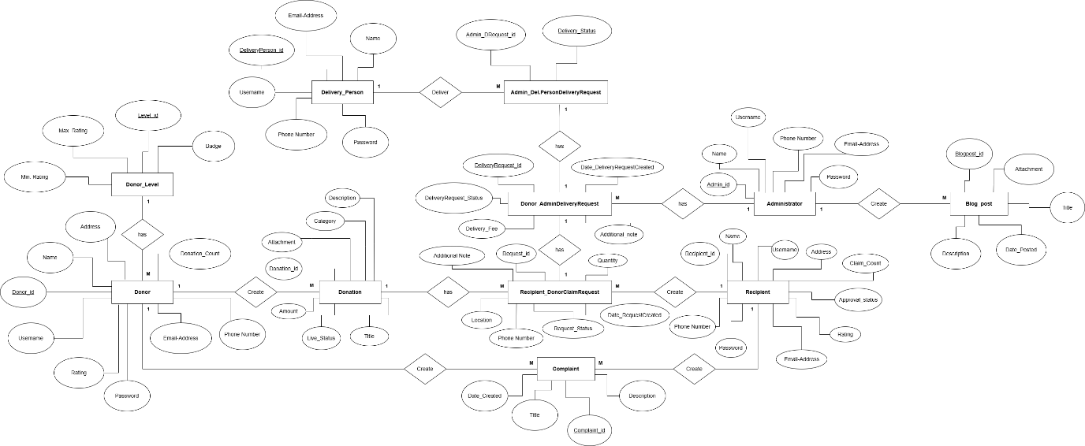

**Normalized Relational Schema**

**Step 01 – Mapping regular entities.**

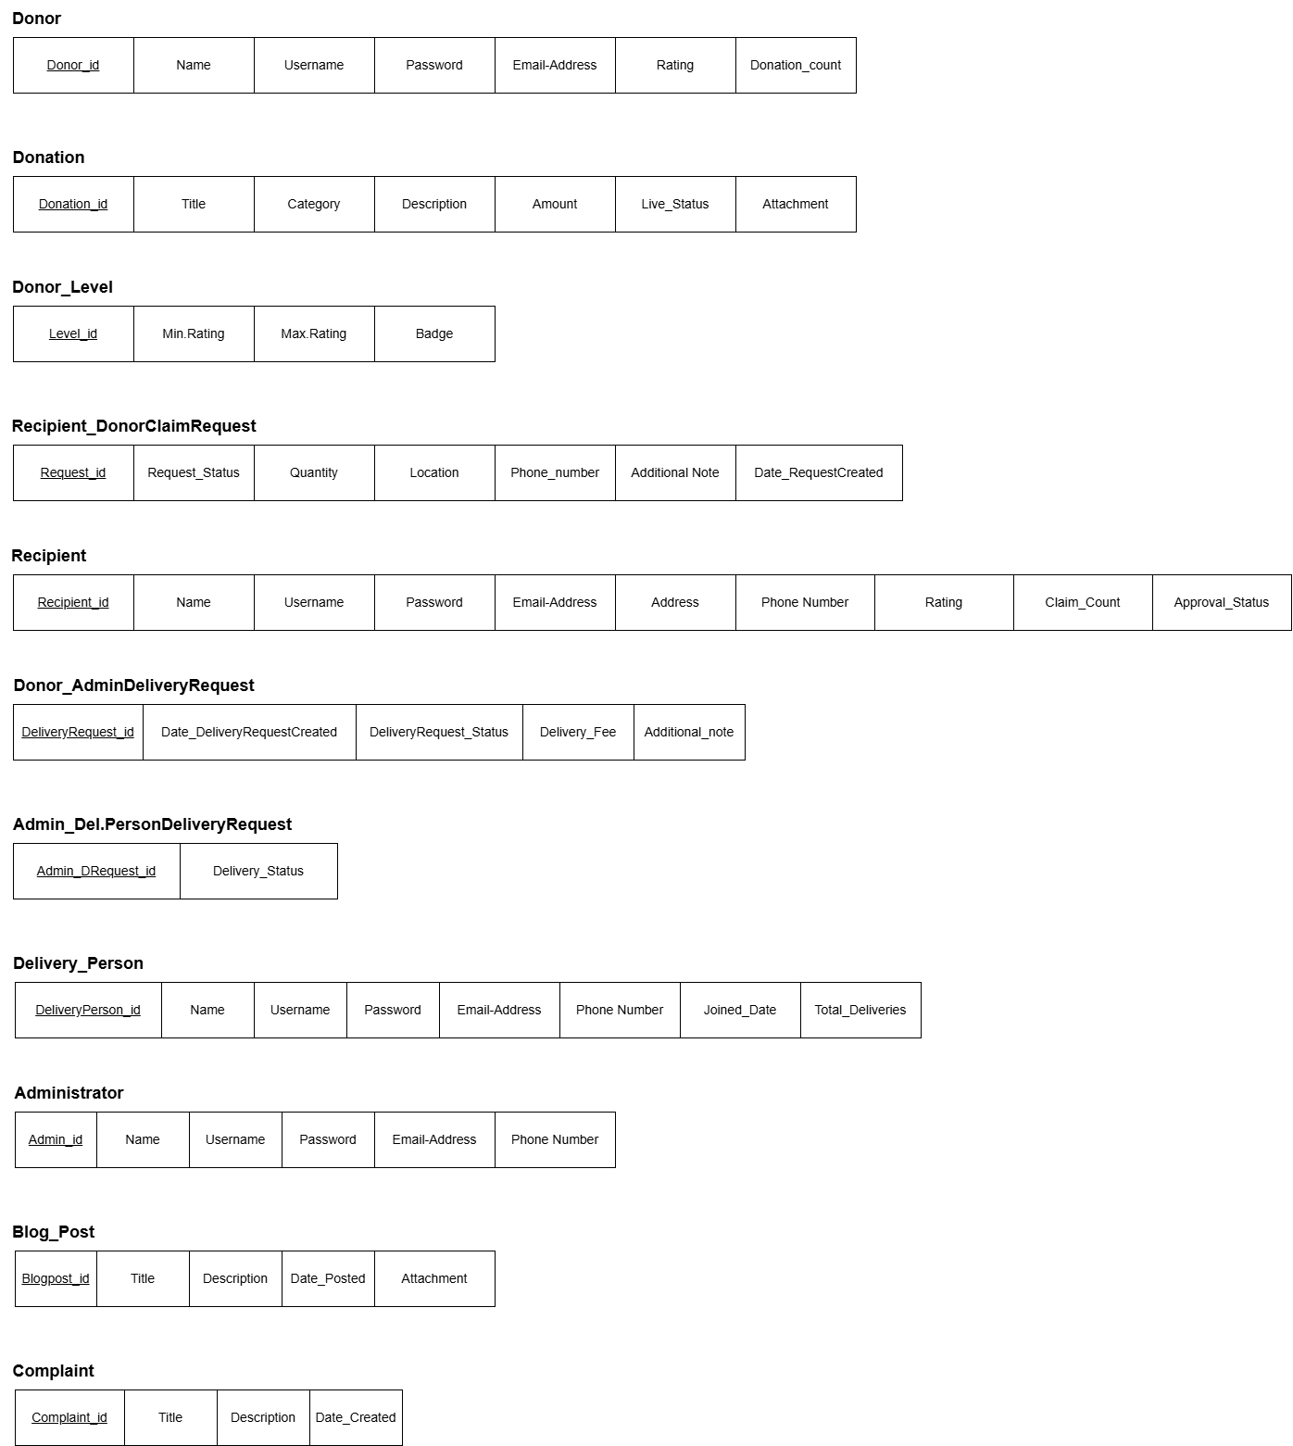

**Step 02 – Mapping 1:1 relationship types**

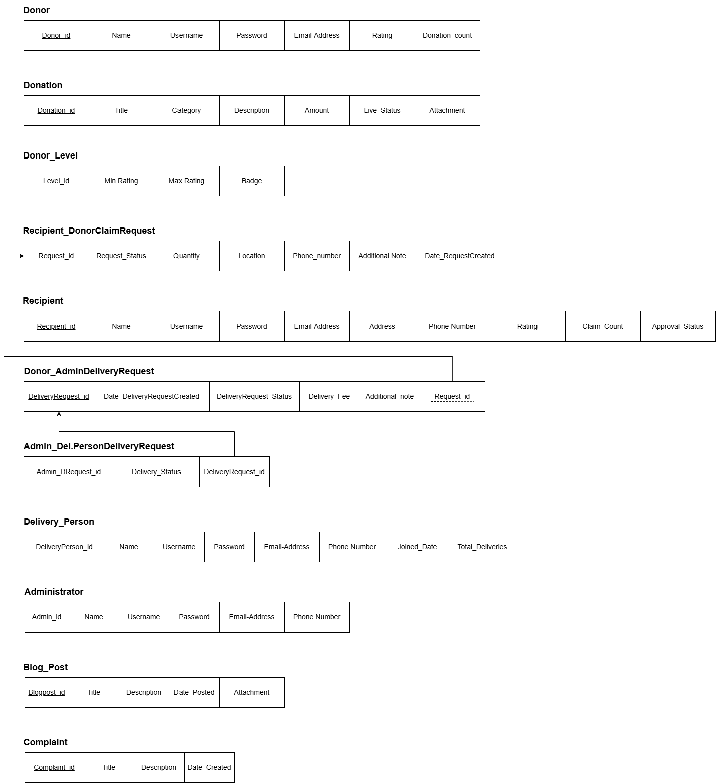

**Step 03 – Mapping 1:M relationship types**

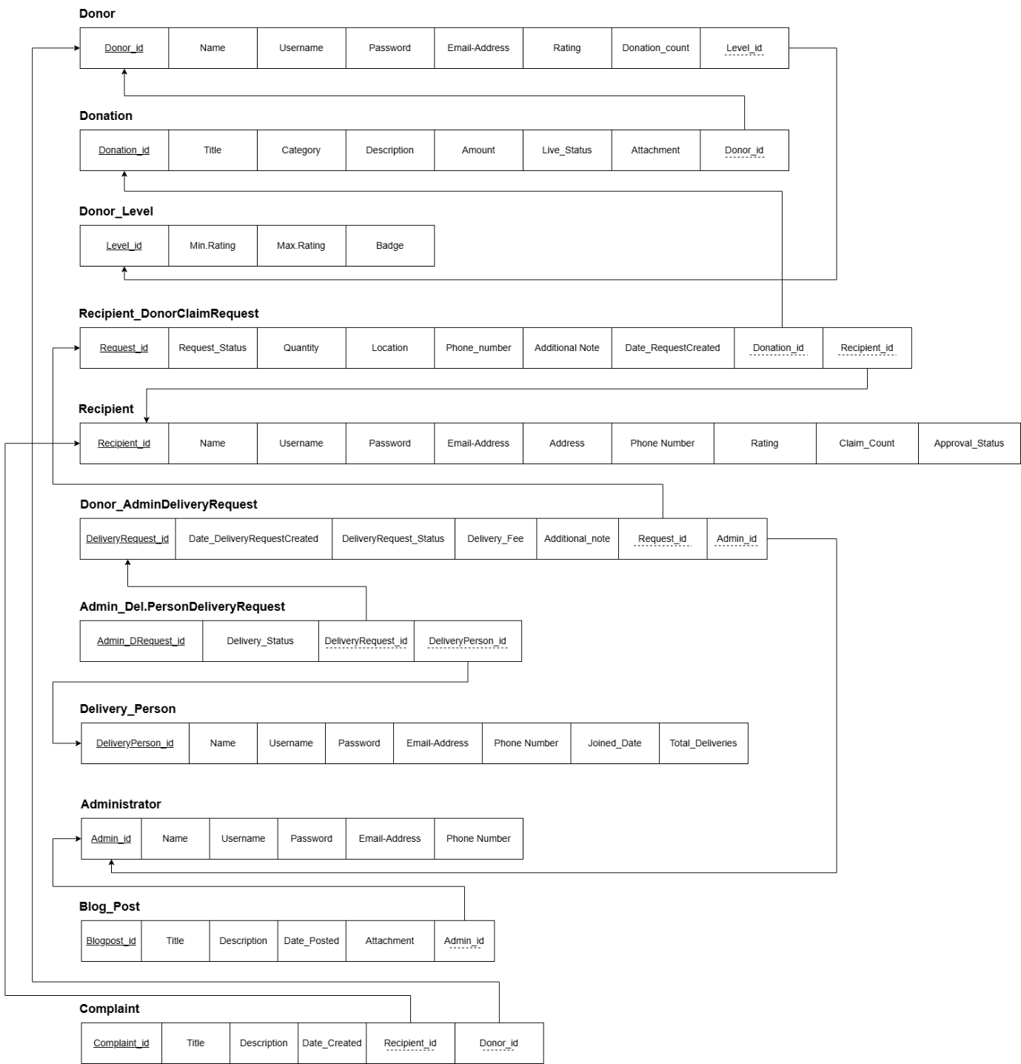

**Step 04 – Mapping M:N relationship types**

No M:N relationships available.

**Final Relational model**



**Context Diagram**

**Level 0 Diagram**

**Level 1 Diagram**



**Use Case Diagram**